**Interview Assignment: 03-07-21**

The goal of this assignment is to build a prototype Flipkart with few features

using React JS.

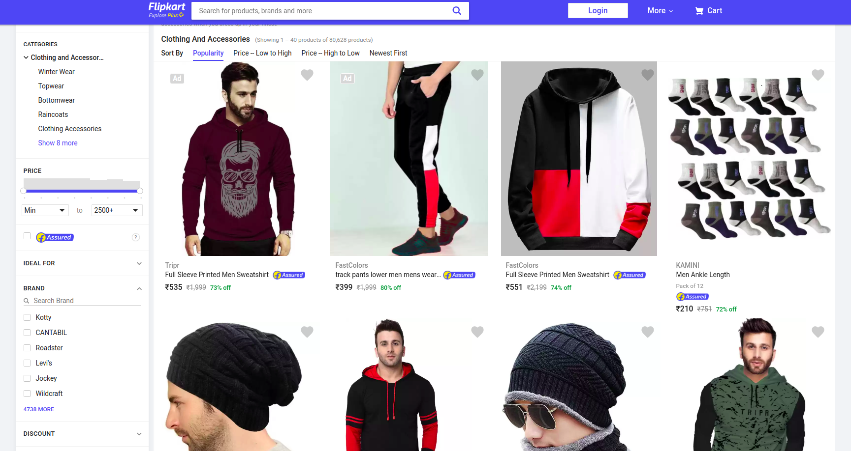

You can refer to [https://www.flipkart.com](https://www.flipkart.com/clothing-and-accessories/pr?sid=clo&otracker=categorytree&p%5B%5D=facets.ideal_for%255B%255D%3DMen&otracker=nmenu_sub_Men_0_Clothing)fordesign ideas and functionality.

**Features to Code:**

1. Create a Flipkart product listing page. A page should contain at least 6 products.
2. Create a JSON file for your products data.
3. Create a feature to sort products from price High-to-Low and Low-to-High.
4. Create Filters based on:
5. Size(S, M, L, XL)
6. Brand
7. Ideal for (Men, Women, etc)
8. Feature to clear all filters.
9. You can use plain CSS or any CSS library you want.

**Guidelines for the interview:**

* For design ideas and functionality: Please refer to <https://www.flipkart.com/clothing-and-accessories/pr?sid=clo&otracker=categorytree&p%5B%5D=facets.ideal_for%255B%255D%3DMen&otracker=nmenu_sub_Men_0_Clothing>
* Please use ReactJS for this problem statement.
* You will be evaluated on
  + Logic and cleanliness of code.
  + The symmetry of design.
  + Reusable components.
  + Completeness of features.
  + Ability to comprehend and complete features on your own. Looking for thought leadership in the feature area.
* Avoid using Jquery.

Took 2hrs 10mins to complete a working model.

Another 30 mins to refactor and add context

Missed on using JSON file for product data.

Implemented Ideal for as a radio button instead of checkbox.

Hosted Link: <https://flipkart-plp.netlify.app/>

Github Link: <https://github.com/supminn/mcr_plp>